**DRAFT TABLES**

**Auburn Valley CSD**

**Water and Sewer Rate Study**

December 12, 2024

**Rate Study Schedule**

December 18: Information only presentation to the Board to review rate study goals and draft results

Early January: L&T submits the rate study report and Proposition 218 notice

January 15: Regularly scheduled Board meeting to approve rate study, set Prop 218 rate hearing date and authorize printing and mailing of notices

January 31: AVCSD prints and mails the notices

Late February/Early March: Publish notice of hearing in the newspaper

March 19: Regularly scheduled Board meeting w/Prop 218 hearing (47 days after postmark; 45 days is the minimum)

April 1, 2025 (Q2): New rates go into effect absent a majority protest

**Table 1: History of Past Rate Increases (Quarterly Rates)**

|  |  |  |  |  |  |  |
| --- | --- | --- | --- | --- | --- | --- |
| **Date** | **Sewer O&M** | **Water O&M** | **Water Meter Charge** | **Total Fixed Fee (Most Customers)** |  | **Water Volume Rate ($/ccf)** |
| 4/3/2004 | $80.25 |  |  | $80.25 |  |  |
| 1/1/2006 | $219.00 | $63.00 |  | $282.00 |  |  |
| 1/6/2007 | $232.14 | $66.78 | $9.54 | $308.46 |  | $2.00 |
| 7/1/2007 | $270.00 | $135.00 | $9.54 | $414.54 |  | $2.00 |
| 7/1/2010 | $270.00 | $135.00 | $28.62 | $433.62 |  | $2.00 |
| 8/1/2014 | $321.00 | $135.00 | $28.62 | $484.62 |  | $2.00 |
| 7/1/2017 | $337.50 | $144.00 | $28.62 | $510.12 |  | $2.40 |
| 10/1/2018 | $337.50 | $144.00 |  | $481.50 |  | $2.40 |
| 10/1/2019 | $345.00 | $120.00 |  | $465.00 |  | $2.40 |
| 10/1/2020 | $345.00 | $120.00 |  | $465.00 |  | $2.40 |
| 10/1/2021 | $375.00 | $135.00 |  | $510.00 |  | $2.40 |
| 7/1/2022 | $382.50 | $137.70 |  | $520.20 |  | $2.45 |
| 7/1/2023 | $390.15 | $140.46 |  | $530.61 |  | $2.50 |
| 10/1/2023 | $444.21 | $160.20 |  | $604.41 |  | $2.50 |

ccf – hundred cubic feet; 1 ccf = 748 gallons

|  |  |  |  |  |
| --- | --- | --- | --- | --- |
| **Table 2: Current Quarterly Water and Sewer Rates** | | | | |
|  |  |  |  |  |
| **Fee or Charge** | **Quarterly Amount** | **Unit** | **Count of Units** | **Estimated Annual**  **Rate Revenue** |
| Base Water Fee | $160.20 | per EDU | 164 | $105,091 |
| Water Volume Rate | $2.50 | per ccf | 39,000 | $97,500 |
| Total Water Rate Revenues | | | | $202,591 |
|  |  |  |  |  |
| Sewer Rate | $444.21 | per EDU | 164 | $291,402 |
|  |  |  |  |  |
| ccf - hundred cubic feet; 1 ccf = 748 gallons | | | | |
| EDU - equivalent dwelling unit; each single family residential customer is assigned one EDU; the golf course is assigned 22 EDUs | | | | |

**Table 3: Capital Improvement Plan**

|  |  |  |  |  |  |  |
| --- | --- | --- | --- | --- | --- | --- |
| **Project #** | **Project Name** | **Priority Level** | **FY2024/25** | **FY2025/26** | **FY2026/27** | **FY2027/28** |
| W-2 | Feasibility Study: NID Piped Water Supply (Bell Rd-Gambah Dr.) [1] | 1 | $13,300 | - | - | - |
| W-3 | Install Isolation Valves (Viewridge & Fairway) already on stock | 2 | $10,000 | - | - | - |
| W-5 | Below Ground Water Reservoir | 2 | - | - | - | $120,000 |
| W-6 | Pump House Electronics | 2 | - |  | - | $54,000 |
| W-7 | Pumps for Wells 3, 6 & 8 | 2 | - | $18,000 | $18,000 | $18,000 |
| W-8 | Well #4 VFD | 3 | $30,000 | - | - | - |
| W-14 | New Domestic Water Well | 3 | $10,000 | $0 | $25,000 | - |
| New | Water Rate Study |  | $5,000 | - | - | - |
|  | **TOTAL WATER PROJECTS** |  | **$68,300** | **$18,000** | **$43,000** | **$192,000** |
| WW-2 | Sanitary Sewer I&I Reduction | 2 | - | - | $30,000 | $120,000 |
| WW-3 | Primary Lift Station Upgrades | 2 | - | - | - | $120,000 |
| WW-4 | Disposal Field Repairs | 2 | - | - | $30,000 | $30,000 |
| WW-5 | Treatment Plant Pump Replacement | 2 | - | - | $12,000 | $12,000 |
| WW-7 | Air Blowers | 2 | - | - | $12,000 | - |
| WW-8 | Pipe Line Camera & Reels | 2 | - | - | $12,000 | - |
| WW-9 | Secondary Lift Station Transmitter | 3 | - | - | $12,000 | - |
| New | Sewer Rate Study |  | $5,000 | - | - | - |
|  | **TOTAL SEWER PROJECTS** |  | **$5,000** | **$0** | **$108,000** | **$282,000** |

1 – Carry over from FY2023/24

**Table 4: Operating Cost Increases**

|  |  |  |  |  |
| --- | --- | --- | --- | --- |
|  | **FY2025/26** | **FY2026/27** | **FY2027/28** | **FY2028/29** |
| **Water System Operating Costs** | | | |  |
| System Operations | 5% | 5% | 5% | 5% |
| Admin & Overhead | 5% | 5% | 5% | 5% |
| General Manager | 5% | 5% | 5% | 5% |
| Repairs & Maint. | 5% | 5% | 5% | 5% |
| Water Testing | 5% | 5% | 5% | 5% |
| Utilities | 5% | 5% | 5% | 5% |
|  |  |  |  |  |
| **Sewer System Operating Costs** | | | | |
| WWTP Operations | 5% | 5% | 5% | 5% |
| Collection System | 5% | 5% | 5% | 5% |
| Admin & Overhead | 5% | 5% | 5% | 5% |
| General Manager | 5% | 5% | 5% | 5% |
| Repairs & Maint. | 5% | 5% | 5% | 5% |
| State License / Fees | 5% | 5% | 5% | 5% |
| Utilities | 5% | 5% | 5% | 5% |

**Table 5: Existing Reserves**

|  |  |  |
| --- | --- | --- |
| US Bank MM #8501-Restr for Bond | $225,420 | not included in the rate study |
|  |  |  |
|  |  |  |
| US Bank Ops #6991 | $59,942 | Source: Draft Audit  as of June 30, 2024 |
| US Bank Money Market #1805 | $125,313 |
| Total Reserves | $185,254 |
|  |  |  |
| 52.6% Allocation to Water Utility [1] | $97,387 | July 1, 2024 Beginning Balance |
| 47.4% Allocation to Sewer Utility [1] | $87,867 | July 1, 2024 Beginning Balance |
|  |  |  |
|  |  |  |
|  |  |  |

1 - Currently, the District comingles its water and sewer cash balances. The allocation shown

here is based on operating results over the past two years.

**Table 6: Water Cash Flow**

|  |  |  |  |  |  |
| --- | --- | --- | --- | --- | --- |
|  | **Projected: Years 1 - 5 (Prop 218 Period)** | | | | |
|  | **FY2024/25** | **FY2025/26** | **FY2026/27** | **FY2027/28** | **FY2028/29** |
| Rate Increase | 15.0% | 15.0% | 10.0% | 5.0% | 5.0% |
| Date of Rate Change | April 1, 2025 | Jan 1, 2026 | Jan 1, 2027 | Jan 1, 2028 | Jan 1, 2029 |
|  |  |  |  |  |  |
| **Beginning Fund Balance** | $97,400 | $49,300 | $83,000 | $112,700 | $195,800 |
|  |  |  |  |  |  |
| Revenues w/July 1 Effective Date | 233,000 | 268,000 | 295,000 | 310,000 | 326,000 |
|  |  |  |  |  |  |
| **REVENUES** |  |  |  |  |  |
| Water Rate Revenues [1] | 209,900 | 251,000 | 282,000 | 303,000 | 318,000 |
| Penalty Revenues | 2,000 | 2,000 | 2,000 | 2,000 | 2,000 |
| Subtotal Operating Revenues | 211,900 | 253,000 | 284,000 | 305,000 | 320,000 |
|  |  |  |  |  |  |
| Line of Credit |  |  |  | 192,000 |  |
|  |  |  |  |  |  |
| **EXPENSES** |  |  |  |  |  |
| *Operating & Maintenance* |  |  |  |  |  |
| System Operations | 47,700 | 50,100 | 52,600 | 55,200 | 58,000 |
| Admin & Overhead | 30,000 | 31,500 | 33,100 | 34,800 | 36,500 |
| General Manager (Split) | 12,000 | 12,600 | 13,200 | 13,900 | 14,600 |
| Repairs & Maint. | 10,000 | 10,500 | 11,000 | 11,600 | 12,200 |
| Water Testing | 8,000 | 8,400 | 8,800 | 9,200 | 9,700 |
| Utilities | 84,000 | 88,200 | 92,600 | 97,200 | 102,100 |
| Subtotal O&M | 191,700 | 201,300 | 211,300 | 221,900 | 233,100 |
|  |  |  |  |  |  |
| Net Operating Revenues  (Operating Rev less O&M) | 20,200 | 51,700 | 72,700 | 83,100 | 86,900 |
|  |  |  |  |  |  |
| **Capital Improvements [2]** | 68,300 | 18,000 | 43,000 | 192,000 | 50,000 |
|  |  |  |  |  |  |
| **Debt Service [3]** |  |  |  |  | 48,100 |
| Coverage Ratio |  |  |  |  | 1.81 |
|  |  |  |  |  |  |
| **Total Expenses** | 260,000 | 219,300 | 254,300 | 413,900 | 331,200 |
|  |  |  |  |  |  |
| Total Net Revenues | (48,100) | 33,700 | 29,700 | 83,100 | (11,200) |
|  |  |  |  |  |  |
| **Ending Fund Balance** | $49,300 | $83,000 | $112,700 | $195,800 | $184,600 |
|  |  |  |  |  |  |
| Reserve Fund Target [4] | 95,850 | 100,650 | 105,650 | 110,950 | 164,650 |
| Target Met? | No | No | Yes | Yes | Yes |
|  |  |  |  |  |  |

1 – Water rate revenues for each fiscal year are prorated based on the date of implementation. For example, in FY2025/26, the total rate revenue collected will reflect six months of rate revenue at the prior year’s rate (July 1, 2025 to December 31, 2025) and six months at the new rate (January 1, 2026 to June 30, 2026).

2 – Table 3: Capital Improvement Plan; assumed cost of $50,000 in FY2028/29

3 – The line of credit is assumed to be repaid over 5 years at 8%

4 – 50% of operating costs + annual debt service payment

**Figure 1: Water Cash Flow Chart**

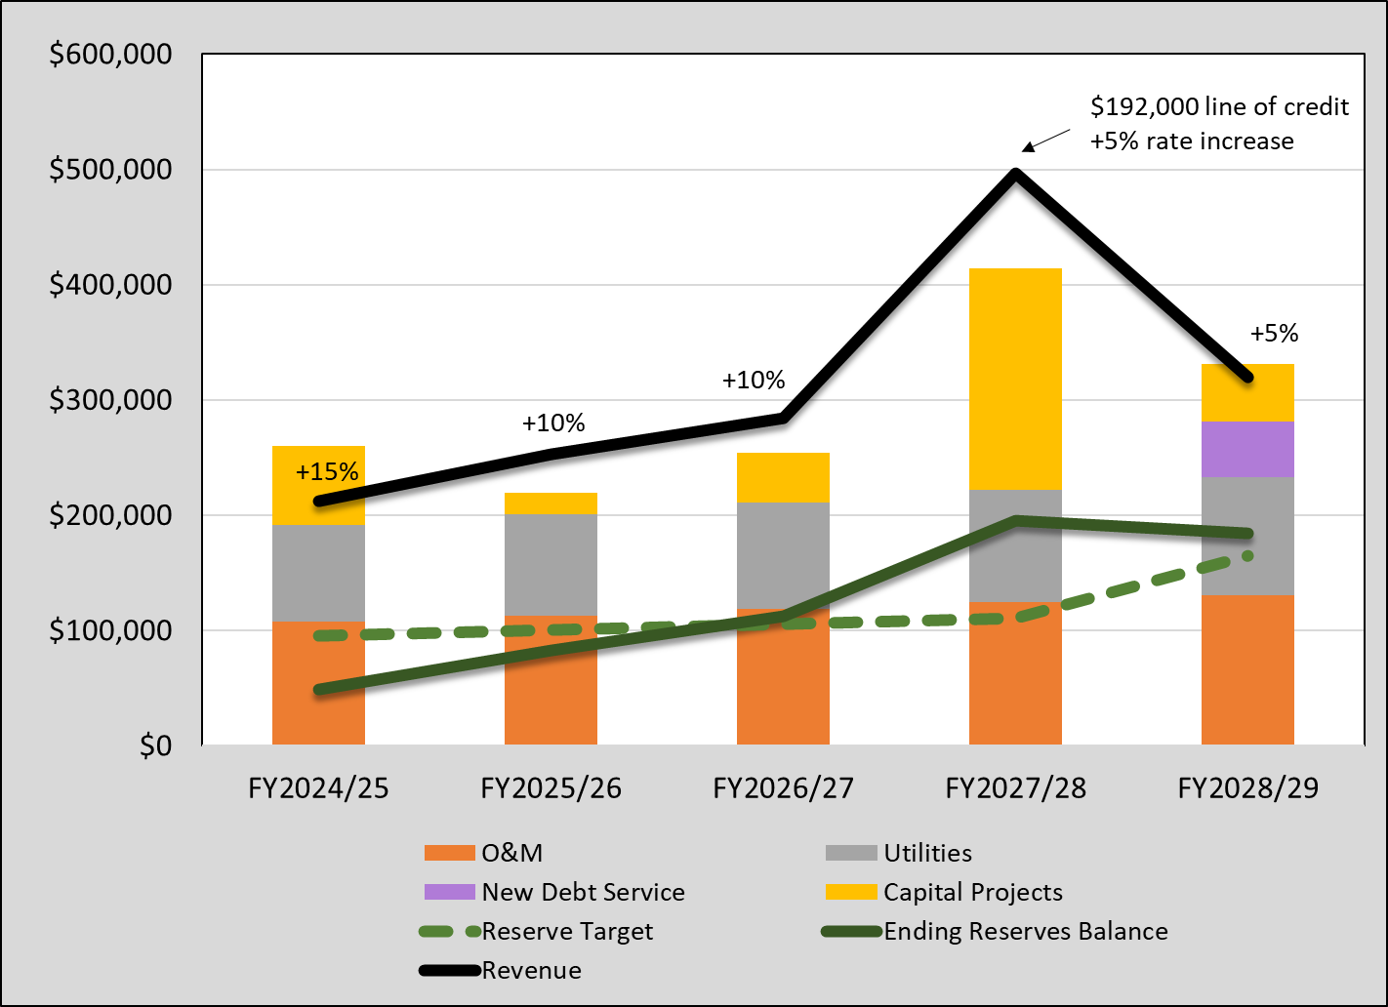

**Table 7: Water Cost Allocation**

|  |  |  |  |  |  |
| --- | --- | --- | --- | --- | --- |
|  | **Projected** | **Base +** | **Meters &** | **Base +** | **Meters &** |
| **Operating Expense** | **2024/25** | **Extra** | **Customer Service** | **Extra** | **Customer Service** |
| System Operations | $47,700 | 100.0% | 0.0% | $47,700 | $0 |
| Admin & Overhead | $30,000 | 0.0% | 100.0% | $0 | $30,000 |
| General Manager (Split) | $12,000 | 0.0% | 100.0% | $0 | $12,000 |
| Repairs & Maint. | $10,000 | 0.0% | 100.0% | $0 | $10,000 |
| Water Testing | $8,000 | 0.0% | 100.0% | $0 | $8,000 |
| Utilities | $84,000 | 100.0% | 0.0% | $84,000 | $0 |
| Total O&M | $191,700 |  |  | $131,700 | $60,000 |
|  |  |  |  |  |  |
| 5-year average CIP | 74,260 | 0.0% | 100.0% | $0 | $74,260 |
| 5-year average debt service | 9,620 | 0.0% | 100.0% | $0 | $9,620 |
|  |  |  |  |  |  |
| Total | $275,580 |  |  | $131,700 | $143,880 |
| Total % | 100.0% |  |  | 47.8% | 52.2% |
|  |  |  |  |  |  |

**Table 8: Water Rate Calculation**

|  |  |  |  |  |  |  |
| --- | --- | --- | --- | --- | --- | --- |
|  |  | **PROJECTED** | | | | |
|  | **FY2024/25** | **FY2025/26** | **FY2026/27** | **FY2027/28** | **FY2028/29** |
|  |  |  |  |  |  |  |
| **REVENUE REQUIREMENT** | Allocation % | [1] |  |  |  |  |
| Base Fee | 52.2% | $121,649 | $139,922 | $154,019 | $161,851 | $170,204 |
| Volume Charge | 47.8% | $111,351 | $128,078 | $140,981 | $148,149 | $155,796 |
| Total Water Revenue Requirement | 100.0% | $233,000 | $268,000 | $295,000 | $310,000 | $326,000 |
|  |  |  |  |  |  |  |
| **WATER FIXED (BASE) CHARGE** | | | | | | |
|  |  |  |  |  |  |  |
| Total Base Fee Revenue Requirement | 7.8% | $121,649 | $139,922 | $154,019 | $161,851 | $170,204 |
| Total No. of EDUs |  | 164 | 164 | 164 | 164 | 164 |
| Total Proposed Quarterly Base Fee | $160.20 | $185.44 | $213.30 | $234.79 | $246.72 | $259.46 |
| *Percent Change* |  | *15.8%* | *15.0%* | *10.1%* | *5.1%* | *5.2%* |
|  |  |  |  |  |  |  |
| **WATER VOLUME FEE** | | | | | | |
|  |  |  |  |  |  |  |
| Total Volume Charge Rev Requirement | 7.8% | $111,351 | $128,078 | $140,981 | $148,149 | $155,796 |
| Total Consumption (ccf) |  | 39,000 | 39,000 | 39,000 | 39,000 | 39,000 |
| Total Proposed Volume Charge | $2.50 | $2.86 | $3.28 | $3.61 | $3.80 | $3.99 |
| *Percent Change* |  | *14.4%* | *14.7%* | *10.1%* | *5.3%* | *5.0%* |
|  |  |  |  |  |  |  |

1 – Hypothetical rate revenue if collected over 12 months; actual rates will only be in effect a portion of the fiscal year – see Table 9

**Table 9: FY2024/25 Water Rate Revenue**

|  |  |  |  |  |
| --- | --- | --- | --- | --- |
|  | | Rate | Revenue |  |
| Current Water Base Fee if Billed July 1, 2024 to March 31, 2025 | | $160.20 | $78,818 |  |
| New Water Base Fee if Billed April 1, 2025 to June 30, 2025 | | $185.44 | $30,412 |  |
| Total Base Revenue |  |  | $109,231 |  |
|  |  |  |  |  |
|  | Usage (ccf) |  |  |  |
| Current Usage Rate if Billed 3 Quarters | 30,110 | $2.50 | $75,275 |  |
| New Usage Fee if Billed Q2 of 2025 | 8,890 | $2.86 | $25,425 |  |
| Total Usage Revenue | 39,000 |  | $100,700 |  |
|  |  |  |  |  |
| Total FY2024/25 |  |  | $209,931 |  |

**Table 10: Proposed Water Rates**

|  |  |  |  |  |  |  |
| --- | --- | --- | --- | --- | --- | --- |
| **RATE CATEGORY** |  | **PROPOSED QUARTERLY WATER RATES** | | | | |
|  | Current | FY2024/25 | FY2025/26 | FY2026/27 | FY2027/28 | FY2028/29 |
| Base Fee | $160.20 | $185.44 | $213.30 | $234.79 | $246.72 | $259.46 |
| Volume Fee | $2.50 | $2.86 | $3.28 | $3.61 | $3.80 | $3.99 |
|  |  |  |  |  |  |  |

**Table 11: Water Rates Breakdown**

|  |  |  |  |  |  |  |
| --- | --- | --- | --- | --- | --- | --- |
| **RATE CATEGORY** |  | **PROPOSED QUARTERLY WATER RATES** | | | | |
|  | Current | FY2024/25 | FY2025/26 | FY2026/27 | FY2027/28 | FY2028/29 |
| Base Fee |  | April 1, 2025 | Jan 1, 2026 | Jan 1, 2027 | Jan 1, 2028 | Jan 1, 2029 |
| O&M |  | $152.57 | $160.21 | $168.17 | $176.61 | $185.52 |
| Reserves |  | $8.33 | $13.46 | $16.88 | $17.77 | $18.74 |
| Capital |  | $24.54 | $39.63 | $49.74 | $52.34 | $55.20 |
| Total Base | $160.20 | $185.44 | $213.30 | $234.79 | $246.72 | $259.46 |
|  |  |  |  |  |  |  |
| Volume Fee |  |  |  |  |  |  |
| O&M |  | $2.35 | $2.47 | $2.59 | $2.72 | $2.86 |
| Reserves |  | $0.13 | $0.21 | $0.26 | $0.27 | $0.29 |
| Capital |  | $0.38 | $0.61 | $0.76 | $0.81 | $0.85 |
| Total Volume | $2.50 | $2.86 | $3.28 | $3.61 | $3.80 | $3.99 |
|  |  |  |  |  |  |  |

**Figure 2: Water Bill Survey**

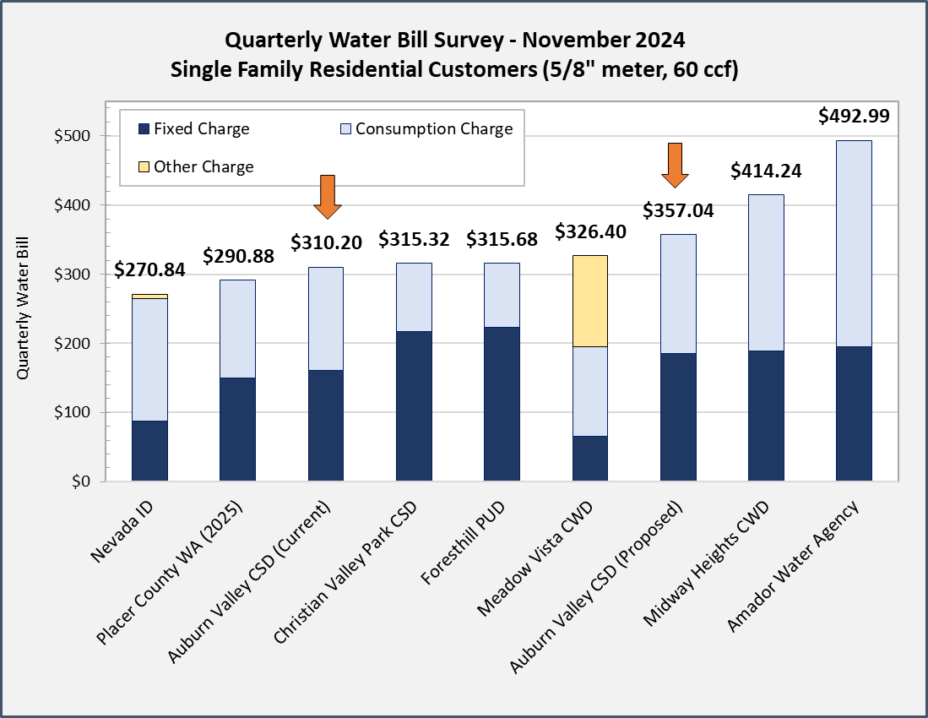

**Table 12: Sewer Cash Flow**

|  |  |  |  |  |  |
| --- | --- | --- | --- | --- | --- |
|  | **Projected: Years 1 - 5 (Prop 218 Period)** | | | | |
|  | **FY2024/25** | **FY2025/26** | **FY2026/27** | **FY2027/28** | **FY2028/29** |
| Rate Increase | 25.0% | 15.0% | 15.0% | 10.0% | 5.0% |
| Date of Rate Change | April 1, 2025 | Jan 1, 2026 | Jan 1, 2027 | Jan 1, 2028 | Jan 1, 2029 |
|  |  |  |  |  |  |
| **Beginning Fund Balance** | $87,900 | $66,100 | $115,100 | $97,800 | $193,300 |
|  |  |  |  |  |  |
| Revenues with July 1 Effective Date | 364,000 | 419,000 | 482,000 | 530,000 | 557,000 |
| Proposed Rate | $554.88 | $638.72 | $734.76 | $807.93 | $849.09 |
|  |  |  |  |  |  |
| **REVENUES** |  |  |  |  |  |
| Sewer Rate Revenues [1] | 309,600 | 392,000 | 451,000 | 506,000 | 544,000 |
| Penalty Revenues | 2,000 | 2,000 | 2,000 | 2,000 | 2,000 |
| Subtotal Operating Revenues | 311,600 | 394,000 | 453,000 | 508,000 | 546,000 |
|  |  |  |  |  |  |
| Line of Credit | 0 | 0 | 0 | 250,000 | 0 |
|  |  |  |  |  |  |
| **Total Revenues** | 311,600 | 394,000 | 453,000 | 758,000 | 546,000 |
|  |  |  |  |  |  |
| **EXPENSES** |  |  |  |  |  |
| *Operating & Maintenance* |  |  |  |  |  |
| WWTP Operations | 161,000 | 169,100 | 177,600 | 186,500 | 195,800 |
| Collection System | 1,400 | 1,500 | 1,600 | 1,700 | 1,800 |
| Admin & Overhead | 28,000 | 29,400 | 30,900 | 32,400 | 34,000 |
| General Manager (Split) | 12,000 | 12,600 | 13,200 | 13,900 | 14,600 |
| Repairs & Maint. | 25,000 | 26,300 | 27,600 | 29,000 | 30,500 |
| State License / Fees | 13,000 | 13,700 | 14,400 | 15,100 | 15,900 |
| Utilities | 88,000 | 92,400 | 97,000 | 101,900 | 107,000 |
| Subtotal O&M | 328,400 | 345,000 | 362,300 | 380,500 | 399,600 |
|  |  |  |  |  |  |
| Net Operating Revenues | (16,800) | 49,000 | 90,700 | 127,500 | 146,400 |
|  |  |  |  |  |  |
| **Capital Improvements** | 5,000 | 0 | 108,000 | 282,000 | 0 |
|  |  |  |  |  |  |
| Debt Service [2] |  |  |  |  | 62,600 |
| Coverage Ratio |  |  |  |  | 2.34 |
|  |  |  |  |  |  |
| **Total Expenses** | 333,400 | 345,000 | 470,300 | 662,500 | 462,200 |
|  |  |  |  |  |  |
| Total Net Revenues | (21,800) | 49,000 | (17,300) | 95,500 | 83,800 |
|  |  |  |  |  |  |
| **Ending Fund Balance** | 66,100 | 115,100 | 97,800 | 193,300 | 277,100 |
|  |  |  |  |  |  |
| Reserve Fund Target [3] | 164,200 | 172,500 | 181,200 | 190,300 | 262,400 |
| Target Met? | No | No | No | Yes | Yes |
|  |  |  |  |  |  |

1 – Sewer rate revenues for each fiscal year are prorated based on the date of implementation. For example, in FY2025/26, the total rate revenue collected will reflect six months of rate revenue at the prior year’s rate (July 1, 2025 to December 31, 2025) and six months at the new rate (January 1, 2026 to June 30, 2026).

2 – The line of credit is assumed to be repaid over 5 years at 8%

3 – 50% of operating costs + annual debt service payment

**Table 13: FY2024/25 Sewer Rate Revenue**

|  |  |  |  |  |
| --- | --- | --- | --- | --- |
|  |  |  |  |  |
| Current Sewer Fee if Billed July 1, 2024 to March 31, 2025 | | $444.21 | $218,551.32 |  |
| New Sewer Base Fee if Billed April 1, 2025 to June 30, 2025 | | $554.88 | $91,000.32 |  |
| Total FY2024/25 Sewer Rate Revenues |  |  | $309,551.64 |  |
|  |  |  |  |  |

**Table 14: Sewer Rate Breakdown**

|  |  |  |  |  |  |  |
| --- | --- | --- | --- | --- | --- | --- |
| **RATE CATEGORY** |  | **PROPOSED QUARTERLY SEWER RATES** | | | | |
|  | Current | FY2024/25 | FY2025/26 | FY2026/27 | FY2027/28 | FY2028/29 |
| Base Fee |  | Apr 1, 2025 | Jan 1, 2026 | Jan 1, 2027 | Jan 1, 2028 | Jan 1, 2029 |
| O&M |  | $500.61 | $525.91 | $552.29 | $580.03 | $609.15 |
| Reserves |  | $25.14 | $52.26 | $84.54 | $105.58 | $111.16 |
| Capital |  | $29.13 | $60.54 | $97.94 | $122.32 | $128.78 |
| Total Base | $444.21 | $554.88 | $638.72 | $734.76 | $807.93 | $849.09 |
|  |  |  |  |  |  |  |

**Figure 3: Sewer Cash Flow Chart**

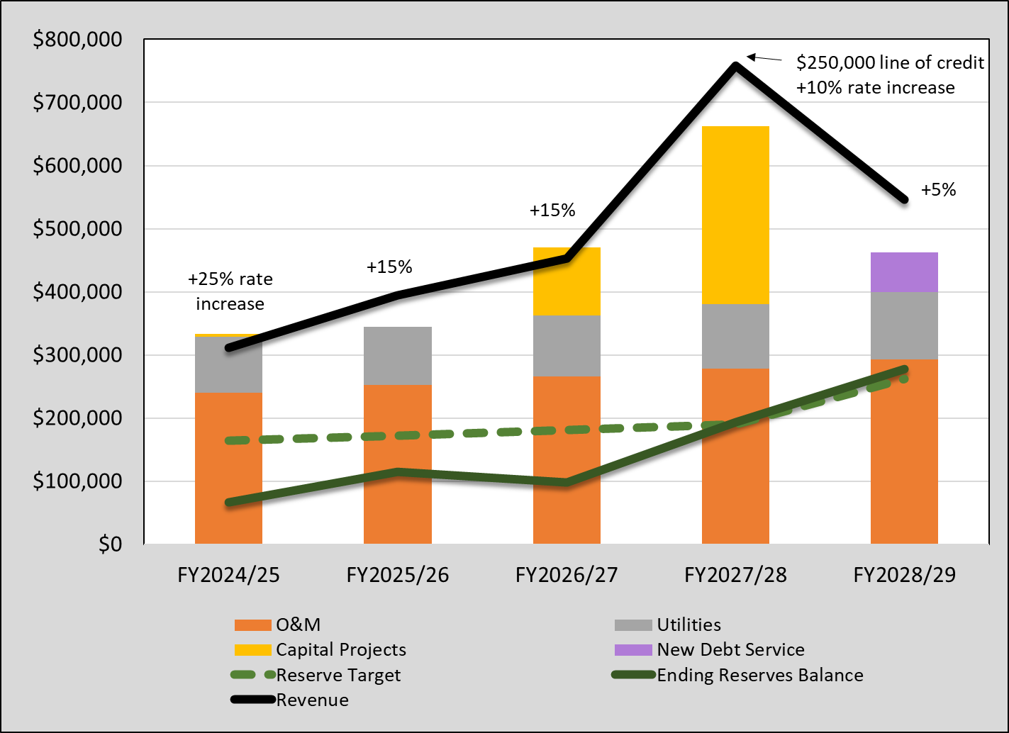

**Figure 4: Sewer Bill Survey**

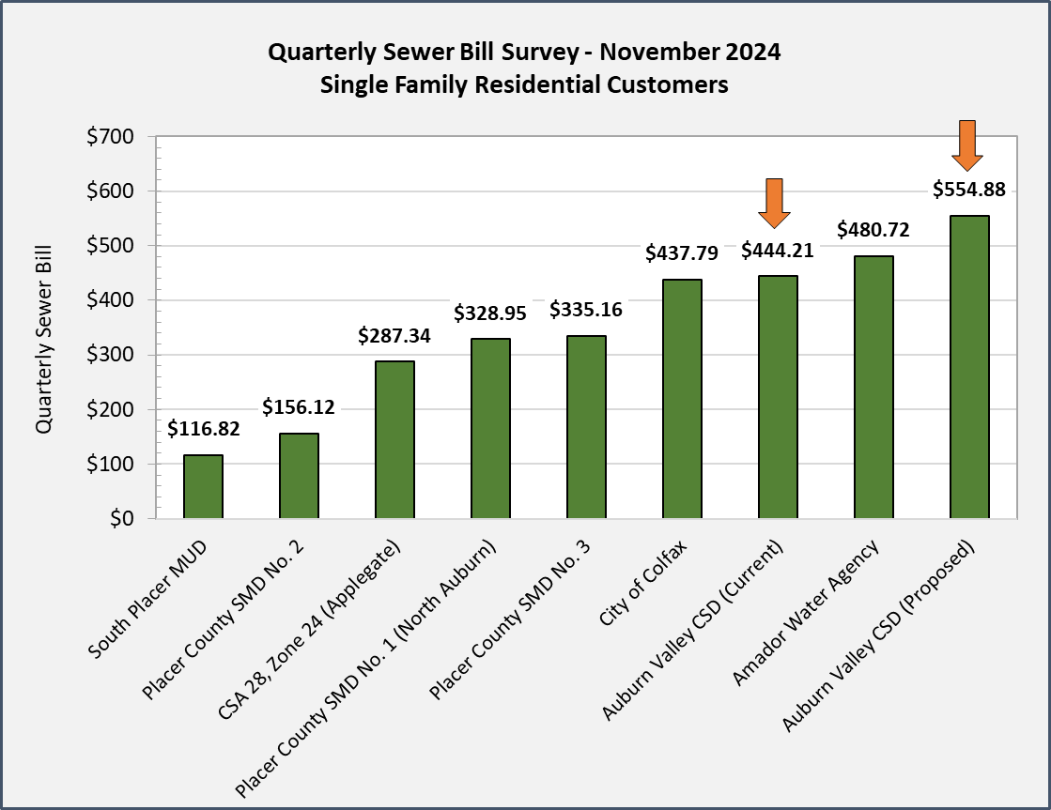

**Table 15: Proposed Utility Rates**

|  |  |  |  |  |  |  |
| --- | --- | --- | --- | --- | --- | --- |
| **RATE CATEGORY** |  | **PROPOSED QUARTERLY RATES** | | | | |
|  | Current | FY2024/25 | FY2025/26 | FY2026/27 | FY2027/28 | FY2028/29 |
| Sewer Base Fee | $444.21 | $554.88 | $638.72 | $734.76 | $807.93 | $849.09 |
| Water Base Fee | $160.20 | $185.44 | $213.30 | $234.79 | $246.72 | $259.46 |
| Volume Fee | $2.50 | $2.86 | $3.28 | $3.61 | $3.80 | $3.99 |
|  |  |  |  |  |  |  |

**Table 16: Current and Proposed Sample Bills**

|  |  |  |  |  |  |  |  |  |  |  |  |
| --- | --- | --- | --- | --- | --- | --- | --- | --- | --- | --- | --- |
| **Current** | | | | | **Proposed FY2024/25** | | | | | | |
| **Fee or Charge** | **Quarterly Amount** | **Unit** | **Count of Units** | **Total** | **Fee or Charge** | **Quarterly Amount** | **Unit** | **Count of Units** | | **Total** | **% Increase** |
| Base Water Fee | $160.20 | per EDU | 1 | $160.20 | Base Water Fee | $185.44 | per EDU | 1 | | $185.44 |  |
| Water Volume | $2.50 | per ccf | 60 | $150.00 | Water Volume | $2.86 | per ccf | 60 | | $171.60 |  |
| Total Water Bill |  |  |  | $310.20 | Total Water Bill |  |  |  | | $357.04 | 15% |
|  |  |  |  |  |  |  |  |  | |  |  |
| Sewer Fee | $444.21 | per EDU | 1 | $444.21 | Sewer Fee | $554.88 | per EDU | 1 | | $554.88 | 25% |
|  |  |  |  |  |  |  |  |  | |  |  |
| **Total Quarterly Bill** | | |  | **$754.41** | **Total Quarterly Bill** | | |  | **$911.92** | | 21% | |
| Monthly Equivalent Bill | | |  | $251.47 |  |  |  |  | | $303.97 |  |
|  |  |  |  |  |  |  |  |  | |  |  |